**CMP1202: ELECTRONICS II**

**ASSIGNMENT**

**DUE DATE: MARCH 27, 2019 AT 10:00 AM**

**Instructions:** *This is a group assignment. Each group should consist of* ***FIVE (5)*** *members. Any extra students should join one of the groups. The work should be typed and printed.*

*Use proper grammar and format your work well i.e. the work should be neat. Number pages.*

*Avoid* ***plagiarism*** *(copying from others). Plagiarized work will be awarded zero marks.*

*Indicate the group name and group members (name, registration number and signature in alphabetical order and contribution) on the cover page of your work.*

*For the simulations indicate the part numbers of opamps and transistors used, give both the circuit diagram and the results (waveforms). Also specify the simulation package used and a brief tutorial on how it is used.*

*Also send a copy of your work to 2012shil@gmail.com.*

**Question 1**

Design a circuit to achieve the output $V_{o}= \frac{V_{1}}{8}+ \frac{V_{2}}{4}+ \frac{V_{3}}{2}+V_{4}$. The inputs Vi can either be at 5 V or 0 V representing logic high and low respectively. This is a simple implementation of a Digital to analog converter. Simulate your circuit with any allowed assignment of values to the input. Compare with the theoretical outputs.

**Question 2: BJTS**

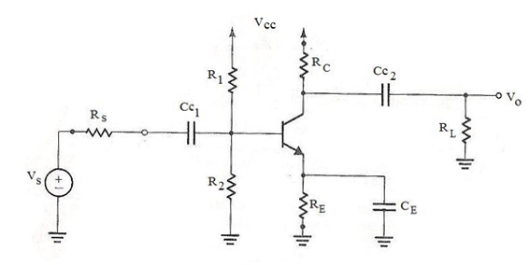

Figure 1

For the common emitter amplifier shown in Figure 1 the resistance values are Rs = 4 kΩ, R1 = 8 kΩ, R2 = 4 kΩ, RE = 3.3 kΩ, Rc = 6 kΩ and RL = 4 kΩ. The supply voltage Vcc = 12 V. The capacitances are Cc1 = 10 μF, Cc2 = 10 μF and CE = 100 μF.

1. Show that the d.c. emitter current IE = 1 mA.
2. Determine the voltage gain Vo/Vs, input resistance, output resistance and current gain of the amplifier. Explain assumptions made.
3. Assume Vs is a sinusoidal function with a small peak value and frequency of your choice e.g. Vs = 5 sin (100t) mV.

Obtain the waveforms for

1. Vs
2. Vb
3. Vo
4. ib
5. ic.

Determine the voltage gain and compare with the gain determined in ii). Explain any discrepancies.

**Question 3**

Design a simple control circuit that turns a LED on in darkness and turns it off when there is light. Give a circuit, explain components and operation. Use simulations where applicable. **Hint**: use the common emitter amplifier, at the input include a light detecting device and at the output a LED.

END